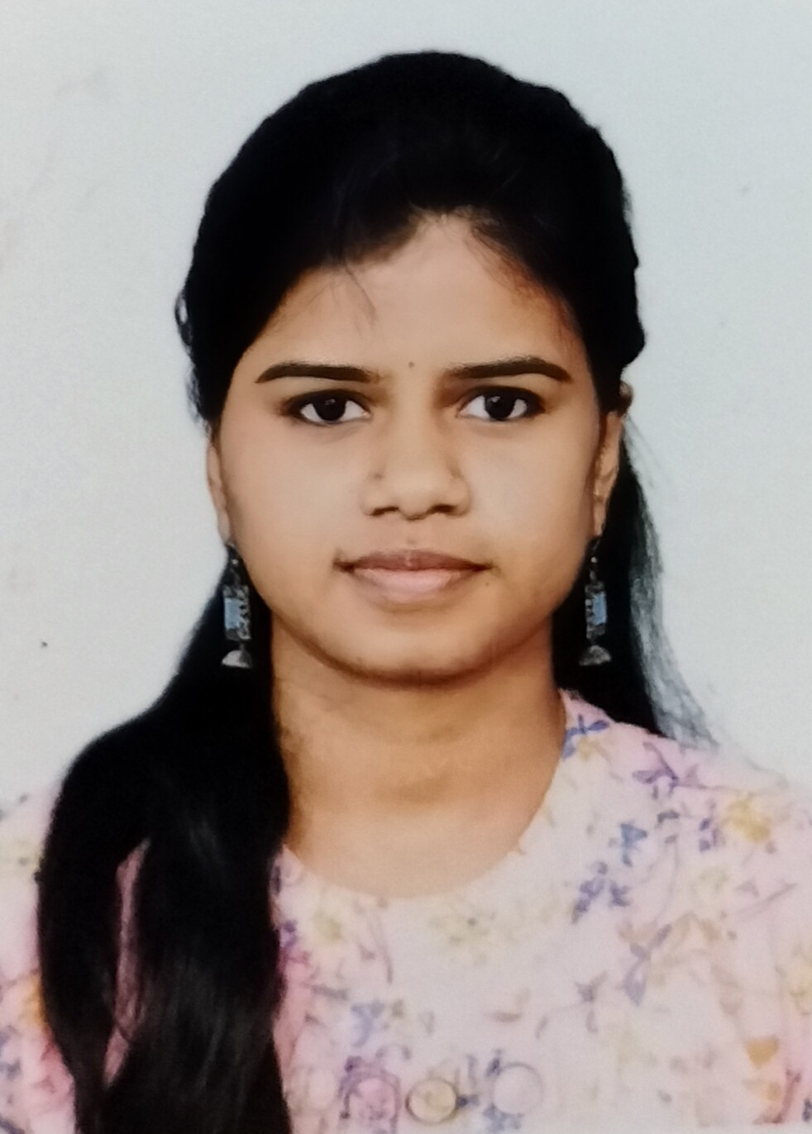

**Skills**

Dot Net ( C# )

Android Studio ( Kotlin ) MongoDB, SQL

Angular , HTML, CSS, Bootstrap

Java, Python

**Field of Interest**

Software Development Software Architect

Mobile Application Development

Siva Ranjani Raja

[sivaranjaniraja1996@gmail.com](mailto:sivaranjaniraja1996@gmail.com) 9176718366

B 65/2 Lalbahadur Sasthri Street, Sathiya Moorthi Block, Chennai - 600 083

# Objective

I am an enthusiastic person who intend to be a part of an organization

where I can constantly learn, develop and share my technical and

programming skills and implement it for the growth of the organization.

# Academic Details

## Anna University

M.Sc Computer Science , 70%, 2023

## Justice Basheer Ahmed Sayeed College for Women

B.Sc, 60%, 2017

## M.A.K Matriculation Higher Secondary School

HSC, 80%, 2014

## M.A.K Matriculation Higher Secondary School

SSLC, 87%, 2012

# Work Experience

## ACL Digital

Software Engineer Trainee , Feb 2022 - till date

Role : Completing all tasks set by the supervisor and assisting whatever possible.

Observing existing strategies and techniques and offering suggestions for improvement.

Researching, investigating and fixing some minor bugs. Working knowledge of Dot net framework and Android Studio.

# Project Details

## Telenta AB Harmoni

Telenta Harmoni is a digital platform specially developed for municipal health care needs. With a digital and cloud-based solution, it offer services and functions that provide a safer everyday life for care recipients, provide support and free up time for care staff, and make it easier and more efficient for management.

Period : August 17 to till date Team Size: 7 Role : Software Engineer Trainee

# Strength

Problem solving Adaptability Team work

Time Management

# Declaration

I hereby declare that the above-mentioned information is correct up to my knowledge and I bear the responsibility for the correctness of the above-mentioned particulars.

Date : 31/03/2023 Place : Chennai

(Siva Ranjani Raja)